Site: Crown Jewels
Tittle:
Mother’s Day Special – Up to 70% OFF on All Clearance Jewelry Deals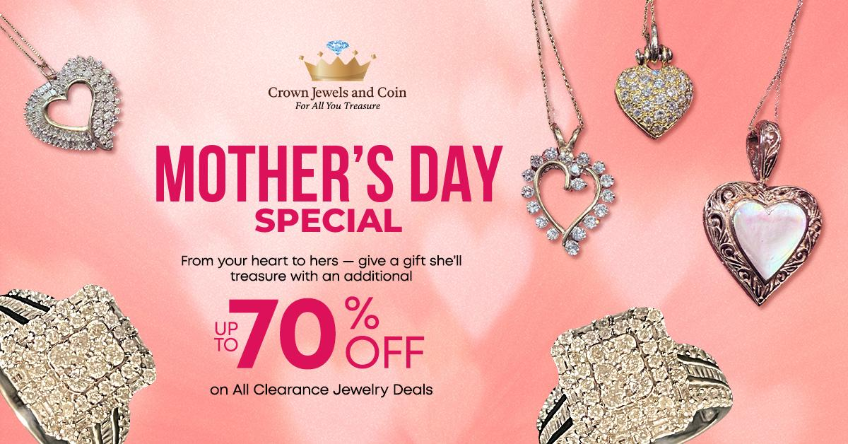
Keywords use in blog
Mother's Day jewelry gift ideas
- Clearance jewelry sale 2025
- Affordable Mother’s Day gifts
- Discounted necklaces for moms
- Mother's Day rings on sale
- Budget-friendly jewelry gifts
- Up to 70% off jewelry sale
- Shop jewelry deals online
- Best jewelry discounts for moms

Anchor Text
Clearance Section:

https://crownjewelsandcoin.com/collections/clearance
Meta Description:
Save up to 70% on Mother's Day jewelry gifts at Crown Jewels & Coin. Shop clearance rings, necklaces & earrings now! Affordable luxury awaits.

Mother’s Day Special – Up to 70% OFF on All Clearance Jewelry Deals H1
Hey Albuquerque! It’s your friends at Crown Jewels & Coin, the best jewelry store in town, and we’re here to let you in on a secret: Mother’s Day just got WAY more glittering. This year, we’re doing something wild, slashing prices up to 70% OFF on our hottest clearance pieces. Yep, you read that right. Whether your mom’s a diamond devotee, a gemstone guru, or a lover of luxury-for-less, our Clearance Section is stacked with affordable Mother’s Day gifts that’ll make her squeal. Ready to dive in? Let’s go!

Why Our Clearance Sale is THE Move for Mother’s Day H2
Let’s cut to the chase: Clearance jewelry sale 2025 is not your average “last season’s leftovers.” We’re talking jaw-dropping deals on pieces that are still stunning, still stylish, and still 100% Crown Jewels & Coin quality. Think discounted necklaces for moms, Mother’s Day rings on sale, and earrings so pretty they’ll make her Instagram feed pop, all without torching your wallet. And here’s the kicker: These pieces are already crowd favorites. Our Morganite and Diamond Ring? It sold out twice last year at full price. Now it’s back and cheaper! Pro Tip: Snag a budget-friendly jewelry gift now, and thank us later when you’re her favorite kid.

Here’s the Tea on What’s Hot in Our Clearance Section H2
We’re spilling ALL the details. Here’s a sneak peek at the best jewelry discounts for moms hiding in our sale:

1. Rings That Scream “Queen Energy” H3
- Morganite and Diamond Ring: Blush pink Morganite + icy diamonds = instant heart-eyes. Fun fact: Morganite symbolizes love and compassion and perfect for the mom who’s everyone’s shoulder to cry on.
- Platinum Diamond Ring: For the mom who loves sleek, modern vibes. Pair it with her work blazer or little black dress, instant boss energy.
- Floral Diamond Ring: Literal garden-on-your-finger vibes. Perfect for plant moms! Bonus: It’s a sneaky nod to her rosebush obsession.
- Men’s Nugget Ring: Got a rockstar dad who deserves love, too? Say less. Rugged yet refined, it’s ideal for dads who grill hard and love harder.
Why It Works: Mother’s Day rings on sale mean you can gift heirloom-quality shine without the splurge.

2. Necklaces That Say “I Love You” Louder Than Words H3
- Diamond Flower Pendant Necklace: Delicate, feminine, and so her. Layer it with the 10K Diamond Cross Pendant for a faith-meets-fashion moment.
- 14K Amethyst Heart Pendant: Purple = royalty. Treat her like the queen she is. Psst… Amethyst is February’s birthstone and ideal for winter babies!
- 10K Diamond Cross Pendant: A timeless symbol of love and faith. Gift it to the mom who starts her day with prayer and an oat milk latte.
Pro Tip: Stack two discounted necklaces for moms (like the heart + flower pendant) for a trendy look she’ll flaunt all year.

3. Earrings That’ll Make Her Blink Back Happy Tears H3
- 14K Sapphire Earrings: Bold blue gems that match her favorite jeans. Fun hack: These double as her “something blue” if she’s renewing vows!
- 18K Garnet Flower Studs: Subtle red hues for the mom who loves a pop of color. Garnet = January’s birthstone, great for Capricorn queens.
- 10K Flower Stud Earrings: Dainty blooms that scream spring. Ideal for the mom who’s always in a sundress.
Why It Works: Studs, drops, or hoops are budget-friendly jewelry gifts that start at prices that’ll shock you (we’re talking under than you can imagine).

4. For the Guys? Yep, We’ve Got Them Covered Too H3
- 14K Men’s Diamond Ring: Understated elegance for Dad. Perfect for dads who rock dad jokes and dad sneakers.
- Men’s Nugget Ring: Rugged, bold, and perfect for the grill master. Pair it with a “#1 Dad” apron for maximum eye-rolls (and hugs).

How to Shop This Sale Like a Pro? H3
- Speed is Key: These up to 70% off jewelry sale pieces are flying faster than free samples at the State Fair. Refresh our Clearance Section daily, and new drops happen at 9 AM MT!
- Filter by Metal or Gem: Use our “Shop Jewelry Deals Online” tool to sort by her faves (gold, silver, sapphire, etc.). Hot filter alert: “Under $500” is a fan fave.
- Size Matters: Check our sizing guide because nothing kills vibes like a too-tight ring. Don’t stress! We offer free resizing on most rings.
- Bundle & Save: Grab a Diamond Flower Pendant Necklace + matching 14K Diamond Earrings for a coordinated gift set. Boom, instant “Best Child” award.
Pro Tip: Bookmark our Clearance Section and set phone alerts. That Platinum Diamond Ring won’t wait forever!

Wait… Why Is Crown Jewels & Coin the BEST for Mother’s Day? H2
Glad you asked!
- Quality You Can Trust: Every clearance piece is polished, inspected, and ready to dazzle.
- Free Gift Wrapping: Because you’re busy, and we’ve got your back.
- Easy Returns: Changed your mind? No stress, we make it painless.

Real Talk: Why Moms Deserve This Sale H3
Let’s be honest: Moms are the OG superheroes. They’ve earned more than a last-minute card. Surprise her with a Diamond Flower Pendant Necklace that’s as radiant as her smile, or a Platinum Diamond Ring that’s as strong as her coffee. And hey, with up to 70% off, you can finally gift that “wow” piece you’ve both been eyeing.
Mic Drop Moment: Our affordable Mother’s Day gifts let you spoil her and stick to your budget. Winning!

Ready to Make Mom’s Day? Here’s Your Game Plan H3
- Click “Shop Jewelry Deals Online”: Browse our clearance section from your couch..
- Filter by Price: Find steals under 1000
- Add to Cart: Proceed to checkout before someone else swipes your treasure.
P.S. Don’t forget hypoallergenic options for sensitive skin!

Final Word: Don’t Miss Out! H3
Albuquerque, this Mother’s Day jewelry gift ideas bonanza won’t last forever. Once these best jewelry discounts for moms are gone, they’re gone. So grab that Morganite and Diamond Ring, snag those 14K Sapphire Earrings, or go big with a Platinum Diamond Ring: all while saving big.
Your Move: Head to Crown Jewels & Coin online or sprint to our store. Because Mom’s worth it, and so are you.
GMB
Hey Albuquerque! Mother’s Day 2025 just got a whole lot brighter with Crown Jewels & Coin, your top spot for the best jewelry deals in town. We’re slashing prices up to 70% OFF on stunning clearance pieces, and trust us, your mom deserves this glittery upgrade. Dive into our Mother’s Day jewelry gift ideas with jaw-dropping steals like the Morganite and Diamond Ring (perfect for the glam mom), the Diamond Flower Pendant Necklace (delicate and dreamy), or the 14K Sapphire Earrings (bold enough to match her personality). Looking for affordable Mother’s Day gifts? Our clearance section is packed with budget-friendly jewelry gifts, from discounted necklaces for moms to timeless Mother’s Day rings on sale. And hey, dads aren’t left out, grab the rugged Men’s Nugget Ring for the grill master in your life. Why shop with us? Every piece is Crown Jewels & Coin quality, polished to perfection and ready to wow. Plus, enjoy free gift wrapping, easy returns, and hypoallergenic options for sensitive skin. Don’t wait, these best jewelry discounts for moms are vanishing faster than breakfast in bed. Visit our Albuquerque store or shop jewelry deals online today. Your mom’s smile? Priceless. These deals? Once-in-a-lifetime.

